DFS for 8 puzzle
Code:
def print_puzzle(state):
for i in range(0, 9, 3):
print(state[i], state[i+1], state[i+2])
print()

def dfs(state, goal, path, visited, limit):
if state == goal:
return path

if len(path) - 1 == limit:
return None

zero = state.index(0)
row = zero // 3
col = zero % 3

moves = [(-1, 0), (1, 0), (0, -1), (0, 1)]

for dr, dc in moves:
new_row = row + dr
new_col = col + dc

if 0 <= new_row < 3 and 0 <= new_col < 3:
new_zero = new_row * 3 + new_col

new_state = list(state)
new_state[zero], new_state[new_zero] = new_state[new_zero], new_state[zero]
new_state = tuple(new_state)

if new_state not in visited:
visited.add(new_state)

result = dfs(
new_state,
goal,
path + [new_state],
visited,
limit
)

if result:
return result

visited.remove(new_state)

return None

start = (5, 4, 6, 1, 8, 0, 7, 3, 2)
goal = (1, 2, 3, 4, 5, 6, 7, 8, 0)

print("Initial State:")
print_puzzle(start)

solution = None

for depth in range(1, 30):
solution = dfs(start, goal, [start], {start}, depth)

if solution:
print("Solution Found at Depth:", depth)
print()

for i, state in enumerate(solution):
print("Step", i)
print_puzzle(state)

break

if solution is None:
print("No solution found")

Output: 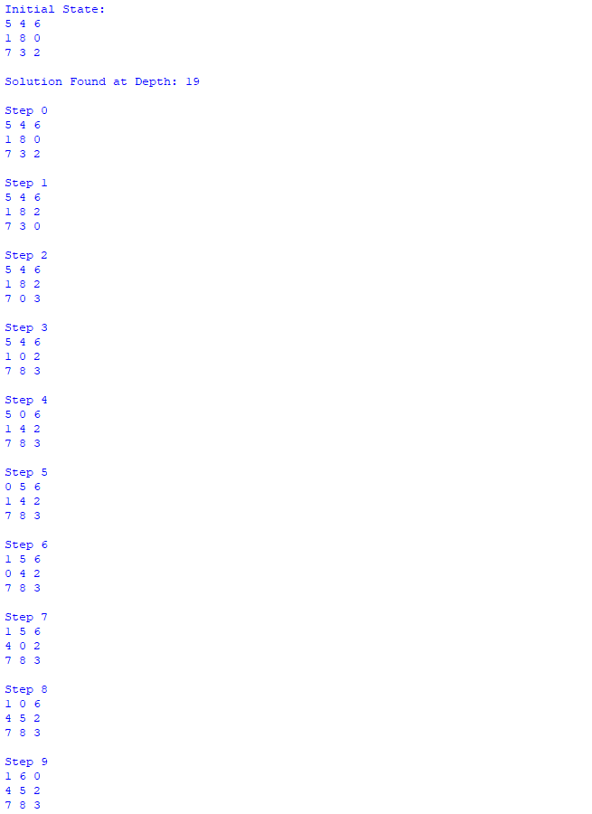
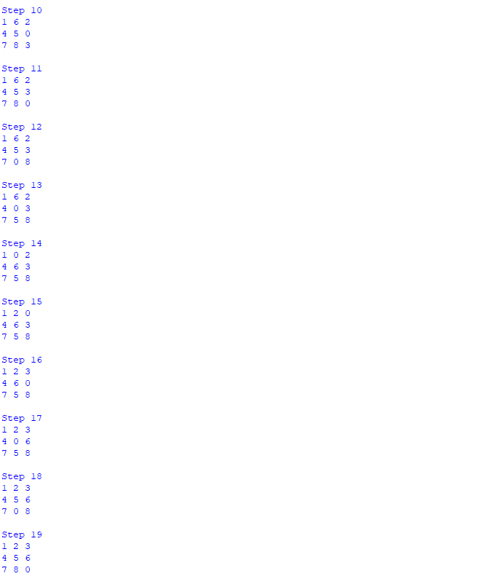

IDS for 8 puzzle

Code:

def print_puzzle(state):
for i in range(0, 9, 3):
print(state[i], state[i+1], state[i+2])
print()

def depth_limited_search(state, goal, path, limit):
if state == goal:
return path

if len(path) - 1 == limit:
return None

zero = state.index(0)
row = zero // 3
col = zero % 3

moves = [(-1, 0), (1, 0), (0, -1), (0, 1)]

for dr, dc in moves:
new_row = row + dr
new_col = col + dc

if 0 <= new_row < 3 and 0 <= new_col < 3:
new_zero = new_row * 3 + new_col

new_state = list(state)
new_state[zero], new_state[new_zero] = new_state[new_zero], new_state[zero]
new_state = tuple(new_state)

if new_state not in path:
result = depth_limited_search(
new_state,
goal,
path + [new_state],
limit
)

if result:
return result

return None

def ids(start, goal):
for depth in range(30):
result = depth_limited_search(
start,
goal,
[start],
depth
)
if result:
return result, depth
return None, None
start = (5, 4, 6, 1, 8, 0, 7, 3, 2)
goal = (1, 2, 3, 4, 5, 6, 7, 8, 0)
print("Initial State:")
print_puzzle(start)
solution, depth = ids(start, goal)
if solution:
print("IDS Solution Found at Depth:", depth)
print()
for i, state in enumerate(solution):
print("Step", i)
print_puzzle(state)
else:
print("No solution found")

Output:
